BREWSTER COUNTY
COMMISSIONERS COURT
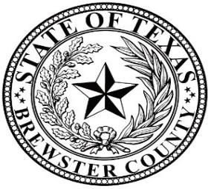
JIM WESTERMANN SARA COLANDO Commissioner, Pct.1 Commissioner, Pct. 2

RUBEN ORTEGA MO MORROW
Commissioner, Pct. 3 Commissioner, Pct.4

GREG P. HENINGTON
County Judge

Special Commissioners Meeting: March 5, 2024, at 4:00 P.M.

Alpine City Council Chambers
803 West Holland Alpine, Texas 79830

AGENDA

- Call to Order
Catherine Eaves, City Mayor, called the meeting to order at 4:01 p.m. Judge Henington stated this is a Special Meeting joined with the City Board Members. The following Elected Officials were present:
Greg Henington, County Judge
Jim Westermann, Commissioner Pct. 1
William "Mo" Morrow, Commissioner Pct. 4
Sarah Vasquez, County Clerk

Sara Allen Colando, Commissioner Pct. 2, and Ruben Ortega, Commissioner Pct. 3, were absent.

The following City Elected Board Members were present:
Catherine Eaves, City Mayor
Darin Nance, Ward 3
Martin Sandate, Ward 4
Rick Stephens, Ward 5
Megan Antrim, City Manager

- Workshop: Joint City / County workshop regarding Texas Department of Transportation’s (TxDOT) Railroad Safety Concerns.
Jose A. Bocanegra, TxDOT El Paso District Project Manager, presented the workshop regarding TxDOT Railroad Safety Concerns. Elisa presented the presentation on the TxDOT Railroad Safety Concerns.

- Adjourn
Catherine Eaves called the adjourn at 5:00 p.m.

ATTEST:
____________________ ___________________
Greg P. Henington Sarah Vasquez
Brewster County Judge Brewster County Clerk

